Press Contact: Nicole Myers
tel: 212-580-8029 / 917-609-8029
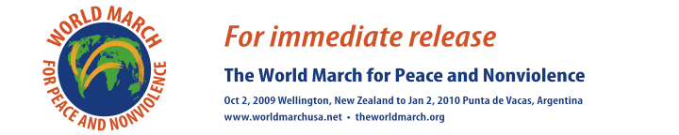

BED IN – 40TH ANNIVERSARY
Give Peace Another Chance: World March for Peace and Nonviolence

Takes Yoko's Bed-In Around the World

CENTRAL PARK, SUNDAY, August 16th, 2009
Cherry Hill Fountain Terrace, adjacent to "Strawberry Fields"
(entrance on 72nd St, Central Park West)

(NEW YORK August 8, 2009) In celebration of the 40th anniversary of Yoko Ono and John Lennon's Bed-In, the organizing committee of the World March for Peace and Nonviolence will be holding a "Bed-In for Peace and Nonviolence" at the Cherry Hill Fountain Terrace in Central Park on August 16th from 1 p.m. – 5 p.m, where they will pay tribute to John Lennon, and Yoko Ono, and the timeless cause of peace. Cherry Hill Fountain Terrace is located adjacent to Strawberry Field inside the park.

A “Peace Bed” will be set-up where the public can express their thoughts on peace, nuclear proliferation and violence just as Lennon and Ono brought attention to the violence of the Viet Nam War from their honeymoon bed. The event will feature activities like sign painting, face painting, poetry reading and a live recording of the new song "We Want Peace on Earth" by Mark Lesseraux and Earthdriver at 3 p.m. The public is invited to sing along.

World March US spokesperson Chris Wells will be on hand to speak to the press. Says Wells, “the Bed-in is a tribute to two remarkable people who dared to dream and used their imagination to promote and support the planet’s most urgent need.” Other Bed-ins have been organized by the World March for Peace and Nonviolence to date in Montreal, Rio, Prague, Helsinki, Ireland, San Clemente, Munich, Madrid and Berlin.

An international team of marchers will kick off the World March in New Zealand on October 2nd, the International Day of Nonviolence and bring together more than one million direct participants in 95 countries on seven continents for thousands of supporting marches, festivals, exhibits, concerts, forums, conferences and social, cultural, educational and athletic events. The goal of the march is to celebrate and demand peace, end wars, dismantle nuclear weapons and eliminate all forms of violence.

The march will arrive in New York City on November 30, 2009, and reach its final destination in Punta de Vacas, Argentina on January 2, 2010.

The World March has been endorsed and backed by more than 500 prominent newsmakers, Nobel Laureates, heads of state, mayors and artists, including Jimmy Carter, Chilean President Michelle Bachelet, Penelope Cruz and Yoko Ono, who has received a special invitation to attend the anniversary event she so famously brought to the world’s attention 40 years ago.

In a special message to March organizers, Ono writes: “Remember, each one of us has the power to change the world. Power works in mysterious ways. You don’t have to do much. Visualize the domino effect. And just start thinking PEACE. The message will circulate faster than you think. It’s Time For Action. The Action is PEACE. Spread the word. Spread PEACE.“

The World March was launched by the international organization World Without Wars and the Humanist Movement. For more information, go: www.worldmarchusa.net

WHAT: BED-IN 40 ANNIVERSARY

WHEN: AUGUST 16TH, 2009
WHERE: CHERRY HILL FOUNTAIN TERRACE (just east of Strawberry Fields, entrance on 72nd St, Central Park West)
WHO: WORLD MARCH FOR PEACE AND NONVIOLENCE

PRESS CONTACT: Nicole Myers 212-580-8029 / 917-609-8029

Event will be held rain or shine.

###

worldmarchusa.net theworldmarch.org

